UNIT 1
Lesson 1 Who are you?
1
1 Harry.
2 Potter.
3 11.
4 Godric's Hollow, England.
5 Yes, an owl, Hedwig.
6 Ron Weasley.
2
1 What is your name?
2 What is your surname?
3 How old are you?
4 Where are you from?
5 Have you got a pet?
6 Who is your best friend?
3
1 What is your surname?
2 What is your name?
3 How old are you?
4 Where do you live?
5 Have you got a pet?
6 Who is your best friend?

Lesson 2 Family tree
1
1 Charlie’s
2 Harry’s
3 Charlie’s
4 Harry’s
5 Harry’s
6 Charlie’s
2
1 his
2 my
3 his
4 Our
5 her
6 Their
3 Students’ own family trees.
4 Students’ own ideas.

Lesson 3 Tia’s Family
1
1 She
2 They
3 He
4 She
5 He
6 It
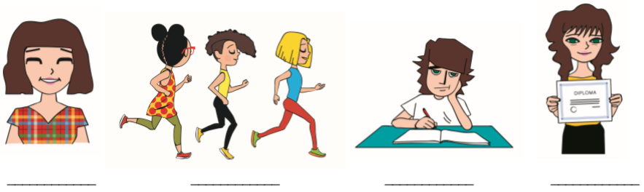
2

c a d b

3
1 is
2 am, is
3 are
4 is
5 are
6 are
4
1 This isn't my best friend, Nicola.
2 My dad isn't 40 years old.
3 My parents aren't in the living room.
4 I am not bored.
5
1 Is this your pencil?
2 Are you 11?
3 Am I late?
4 Is the film interesting?
5 Is Lucy very tall?

6
Suggested questions:
1 happy?
2 you bored?
3 he your best friend?
4 Is she your best friend?
5 Are they your parents?

Lesson 4 My favourite band
1
has got, has got, has got, has got, has got, have got, has got, has got, has got
2
1 have got
2 has got
3 has got
4 has hot
5 have got
6 have got
3
1 I haven’t got a big family.
2 She hasn’t got curly brown hair.
3 My best friend hasn’t got a pet iguana.
4 This cat hasn’t got one blue eye and one orange.
5 I haven’t got a brother and a sister.
6 My parents haven’t got a house in the mountains.
4
1 has got
2 have got
3 has got
4 Have got; have got
5 have got
6 haven’t got
7 Has got
8 hasn’t got

Lesson 5 The letters
1 Students’ own answers.
2
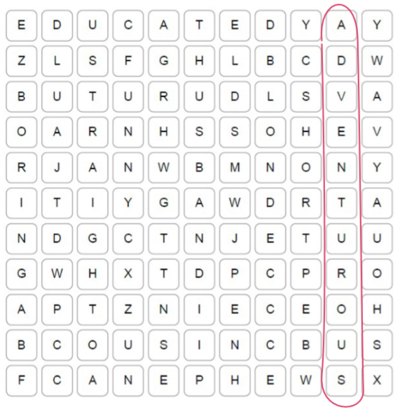

HAIR | FAMILY | PERSONALITY
1 straight  2 blond  3 short  4 wavy | 1 husband  2 niece  3 cousin  4 nephew | 1 adventurous  2 educated  3 boring  4 funny

Lesson 6 The Browns
1
NAME | AGE | HAIR AND EYES | INTERESTS
Anne | 35 | brown hair and green eyes | travelling, reading, cooking, politics
Joseph | 40 | black hair and brown eyes | old computer games, creating new characters for the game
Penelope | 13 | blond hair and green eyes | fashion, art, sports
Noah | 10 | brown hair and brown eyes | football, reading
2
1 sporty
2 boring
3 hard-working
4 kind
5 creative
6 friendly

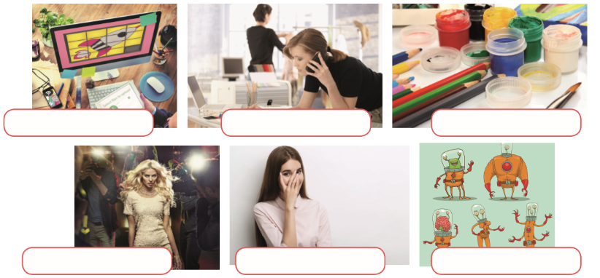
3

aliens
celebrity
shy
game developer
fashion designer
art

Project time
1, 2, 3 and 4 Students' own project.

Lesson 7 Gaming
1 Students' own answers.
2 Students' own answers.
3 Students' own answers.

Self-check 1
VOCABULARY
1
1 grandma
2 uncle
3 cousin
4 husband
5 niece
6 nephew
2
What is Tia like? | What does Tia like? | What does Tia look like?
Tia is interesting.  Tia is friendly.  She isn't boring. | She likes sports, especially swimming. | She is plump and short.  She has always got an unusual hairdo.
3
1 Queen
2 fashion
3 elf
4 rule
5 game
6 shy

GRAMMAR
1
1 I’m not
2 Are
3 isn’t
4 are
5 aren’t
6 am
2
1 is, are, are, has got, is, has got, is, has got, hasn’t got, is
3
1 What is your name?
2 How do you spell your name?
3 How old are you?
4 Have you got a brother?
5 Who is your best friend?
6 What does he look like?
4 Students answer in pairs.

UNIT 2
Lesson 1 My life on the farm
1
1 sink
2 painting
3 armchair
4 curtains
5 pillow
6 washbasin
7 cooker
8 bookshelf
9 table
10 bath

Lesson 2 My room
1
1 is, isn’t
2 are, aren’t
3 isn’t, is
4 are, aren’t
5 are, aren’t
6 is, aren’t
2 a)
between, on, in, next to, under, in front of, behind
2 b)
1 No, there aren't.
2 No, there isn't.
3 Yes, there are.
4 No, there isn't.
5 No, there aren't.
6 No, there isn't.
3 Students' own answers.

Lesson 3 Kira's house
1 a cat, an apple, a plane, a lemon, an orange, a friend, an hour, a school, a house, an armchair, a mouse, an elephant
2
1 a, a, a
2 an, a
3 a
4 an
5 an
6 A, a, a
3
1 There are children in the garden.
2 There are bookshelves on the wall.
3 There are boxes in the kitchen.
4 There are mice in front of the cheese.
5 There are watches on my wrist.
4
a, is, are, a, is, is

Lesson 4 Home sweet home
1 Possible answers:
bedroom: bed, pillow, wardrobe, desk, carpet
bathroom: bath, shower, washbasin, mirror, tap
kitchen: cooker, sink, fridge, drawer, cupboard
living room: TV, sofa, armchair, carpet, painting
2
curtains, armchair, bath, painting, bookshelf, pillow, sofa, desk, fridge, wardrobe
The secret message: There's no place like home!
3 Students' own answers.

Lesson 5 I live at school
1 Possible answers:
Things I like…
1 Harry has a lot of fun living with his friends. 2 Harry and his friends have their own kitchen. 3 They sleep in bunk beds.
Things I don't like…
1 Harry lives with his teachers. 2 Harry shares his room with three or four other boys. 3 They have to tidy up after cooking themselves.
2 Students' own answers.
3
1 a house in which schoolchildren live with their teachers
2 where the main door is
3 two beds on top of each other
4 a room used by everyone
5 a person who repairs things in the school
6 a small table next to your bed
7 space around a house
4 boarding house, teacher, ground floor, bunk- bed, common room, yard

Lesson 6 I love my home
1
1 one room – my bedroom.
2 yard.
3 I can climb.
4 a water pipe.
5 to keep fit.
2 Students' own plans.

Lesson 7 Around the world
1 Possible answers:
In a house.  My mum. | There are six rooms.  There is a kitchen, a dining room, a living room, a bathroom and two bedrooms.
In a bunk bed.  There is a desk, two chairs, a wardrobe and a poster. | My favourite room is my bedroom.  I enjoy my freedom there.

2 Students' own descriptions.

Self – check 2
VOCABULARY
1
1 pillow
2 sink
3 armchair
4 cooker
5 wardrobe
6 painting
2
1 fridge
2 roof
3 front
4 playroom
5 drawer
6 pantry
3
1 boarding
2 janitor
3 cotton
4 sawdust
5 leather
6 brick

GRAMMAR
1 a hamster, an ice cream, an arm, an office, a curtain, a day, a wheel, an ear, a stone
2
1 is
2 is
3 aren't
4 are
5 isn't
6 are
3
1 There are bad teeth in my mouth.
2 There are tomatoes in the basket.
3 There aren't women in the shop.
4 There aren't watches on the table.
5 There are children in the picture.
6 There aren't bookshelves in the cupboard.
4
Crtež Pascala iza sata. | Crtež Pascala između dvije knjige.

UNIT 3
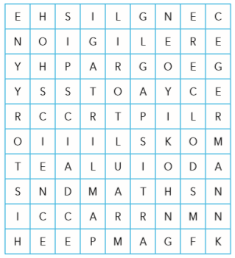
Lesson 1 School subjects
1
1 Croatian
2 PE
3 English
4 Music
5 History
6 Geography
7 Maths
8 Art
9 RE
10 Science
11 German
12 ICT
2
__1__ You learn about our famous writers and poets and read their books and poems.
__8__ You learn how to make sculptures.
__5__ It is about wars and heroes.
4 You learn about famous composers.
__2__ You do it in a gym or in a playground.
__3__ You learn how to speak it.
__6__ You learn about Earth and how to protect it.
__7__ It helps you to deal with money.
3
1 calculate
2 literature
3 draw
4 nature
5 continents
6 past

4


12
13
142
11
102
92
82
62
7
52
42
3
2

5
1 b) 2 a) 3 b) 4 a) 5 a)
6
locker | smartphone

Lesson 2 Me and my school
1
_3_ do sports.
_5__ eat their lunch.
_1_ meet.
_2__ borrow and read books.
_4__ do experiments.
2
You get: dressed, up
You have: breakfast, lunch
You do: homework, experiments
You go: to school, to bed
You take: a shower, a bus
3
1 up 2 experiments 3 to bed 4 a shower 5 homework 6 bus

Lesson 3 Timetables
1
3rd | 8th | 11th | 1st | 9th | 6th
third | eighth | eleventh | first | ninth | sixth
2nd | 5th | 10th | 7th | 4th | 12th
second | fifth | tenth | seventh | fourth | twelfth

2
SCHOOL IS COOL!
3 a) Students' own timetable.
3 b) Answers vary depending on the students' timetable.
4
1 twice 2 once 3 five times 4 three times
5 Students' own preferable timetable.

Lesson 4 Pupil of the month
1 a)
kind – rude
responsible – irresponsible
helpful – selfish
lazy – hard-working
late – on time
1 b)
1 lazy 2 rude 3 selfish 4 on time irresponsible
2
1 lives 2 like 3 speak 4 fly 5 go 6 teaches
7 starts 8 watch
3 has, loves, doesn’t walk, lives, takes, is, plays, plays

Lesson 5 What’s the time?
1
4 10.30 It’s ten thirty.
5 4.15 It’s a quarter past four.
6 11.35 It’s twenty-five minutes to twelve.
2 8.10 It’s ten past eight.
1 4.45 It’s a quarter to five.
3 11.25 It’s twenty-five past eleven.
2
1:00 a)
10:15 b)
7:30 a)
23:10 b)
24:00 a)
3
a) 8.45 b) 5.45

Lesson 6 Happy Friendship Day
1
1 pass on 2 tell 3 hear 4 go 5 live 6 feel
2
1 On 2 about 3 in 4 in 5 with 6 on
3
1 F 2 T 3 F 4 T 5 F 6 T 7 F 8 F

Lesson 7 An interview
1
1 play 2 watches 3 gets up 4 has 5 make 6 eats 7 talk
2 art, important, sports, tennis, piano, CDs, girlfriend, teacher, Saturdays, pizza

Self-check 3
VOCABULARY
1
1 science 2 history 3 maths 4 PE 5 music 6 Croatian
2
7.10 It’s ten past seven.
7.30 It’s half past seven.
7.45 It’s a quarter to eight.
7.25 It’s twenty-five past seven.
7.00 It’s seven o’clock.
3
1 get 2 do 3 have 4 take 5 go 6 have

GRAMMAR
1
1 about 2 in 3at 4 on 5 at in
2 lives, has, are, go, walks, goes, take, goes, is, picks, get, have
3
a second c 1st
b fourth a 2nd
c first d 3rd
d third b 4th
4
1 five times
2 once
3 twice

UNIT 4
Lesson 1 It’s Monday again
1
Monday, Tuesday, Wednesday, Thursday, Friday, Saturday, Sunday
Pascal likes Wednesdays, Fridays, Saturdays and Sundays.
2
1 begin 2 school 3 far away 4 good at 5 beginning 6 hang out
7 end of our lesson

Lesson 2 What to do?
1
5 at home do
6 skiing
1 pizza
2 homework
3 the violin
4 the Internet
2 Students’ own answers.
3 Possible answers:
plays games, stays at home, watches a film, goes to the cinema

Lesson 3 Clubs
1
5 No, I live in Zagreb.
_4__ Yes, she’s a cook.
_2__ No, I sometimes forget to do it.
_1__ Yes! It’s my favourite food.
_3__ Yes, he likes them just as I do.
2
1 Do 2 Do 3 Does 4 Do 5 Do 6 Do
7 Does
3 Students’ own answers.

Lesson 4 Where does the cat sleep?
1 a)
1 Where 2 When 3 What 4 Who 5 Why
1 b) Possible answers:
It takes place at the music hall.
They meet on Monday and Wednesday at 1 p.m. and 2 p.m.
2 Students’ own answers.
Lesson 5 In my free time
1 a)
__5__ pomoći
__1__ sklonište za životinje
4 činiti dobro
__3__ koncentrirati se na nešto
__2__ raditi besplatno
1 b)
1 good
2 out
3 animal shelter
4 for free
5 focus
2
a with, fish, cook
b reading, makes, maths, alone
c helps, animal, happy
d relaxed, helps

Lesson 6 Radio show
_6_ where pet birds and pet hamsters usually live
_5_ you use it in the dark
_2_ what someone can do, but people don’t know about
1 to ask someone to come
_3_ to listen to a radio show
_4_ a toy for hamster
2
1 In 2 around 3 to, about 4 of 5 for 6 in 7 to
Project time
3, 4 and 5 Students’ own projects.

Lesson 7 Call the number
1
112 double one two
911 nine double one
42 66 349 four two double six three four nine
543 552 143 five four three double five two one four three
910 681 260 nine one oh six eight one two six oh
11 887 334 double one double eight seven double three four
2 Class game
3
1 The course is taking place at Queen’s Primary School.
2 The teachers are Mr Newton and Mr Marconi.
3 The robotics course is for school children aged 10 to 14.
4 The phone number is 00 245 7332.
5 It’s free.

Lesson 8 Changing the world
Project time
Students’ own projects.

Self-check 4
VOCABULARY
1
1 spend 2 far 3 end 4 board 5 shelter 6 invite
2
1 make 2 play 3 out 4 in 5 do 6 at
3
385 three eight five
0800 2323 oh eight double oh two three two three
445 566 double four double five double six
4 usually, always, sometimes, often, never
GRAMMAR
1 a) Does 2 Does 3 Do 4 Does 5 Does 6 Do
1 b)
1 5 2 4 3 2 4 3 5 6 6 1
2
1 Where does it take place?
2 When does it start?
3 What do they do there?
4 How often do they meet?
5 What is their phone number?
6 Why is it interesting?
3 Students’ own answers.

UNIT 5
Lesson 1 Ollie’s hometown
1
1 a film 2 a book 3 at the traffic lights 4 the animals
5 the shopping 6 food and milk 7 the street 8 a bus
2
watch | borrow | do | cross | get on
a game show  a ballet | an umbrella  money | sports  homework | a road  a bridge | a train  a tram
3
1 cross 2 get on 3 borrow 4 feed 5 do 6 watch
4
1 bookshop 2 bakery 3 hospital 4 hotel 5 market 6 post office

Lesson 2 Places in my town
1
1 theatre 2 zoo 3 museum 4 library 5 supermarket
6 police station
2
c) police station
a) bakery
b) market
a) hospital
c) hotel
c) restaurant
3
1 next to 2 opposite 3 between 4 across 5 opposite 6 on the corner of

Lesson 3 People in my neighbourhood
1 a)
eat + ing | have + ing | sit + ing
eating | having | sitting
watching | writing | swimming
reading | driving | winning
lauhging | dancing | running
playing | riding | getting
1 b)
1 is singing, dancing
2 are looking
3 is driving
4 is running
5 is playing
2
1 is not feeling, is talking, hospital
2 is standing, is asking, is writing, classroom
3 are standing, are waiting, traffic lights

A MULTITASKING FAMILY
3 a)
1 online 2 email 3 score 4 English 5 homework 6 music
7 kitchen 8 dishes
3 b)
Mum is washing the dishes, writing an email, helping Noah and cleaning up the kitchen.
Sophie is chatting with her friends, doing her maths homework, studying English and listening to music.
4 a)
1 What are the kids talking about?
2 What are you doing in the mall?
3 Why is the zookeeper shouting at the zoo?
4 Where are the tourists staying tonight?
5 Why is she standing in the street?
4 b)
1 2 2 4 3 5 4 1 5 3
5
1 Where are Mandy and Nora singing?
2 What is Mr Davies riding?
3 Who is helping in an animal shelter?
4 Why is Molly in her room?
5 When are the Rileys going on a holiday?

Lesson 4 Let’s party
1 celebrating, craftsmen, beaches, barbecue, surfing, tournament
2 Possible answers:
Picture 1 | Picture 2
They are taking a selfie with a selfie stick. | They are having a barbecue.

Lesson 5 Street party
1 are doing, am doing, are having, is playing, are dancing, are playing, is winning, are having
2 Students’ pair work.
3 Possible answers:
My friend can play a musical instrument.
He/she can ride a bike no handed.
My friend can’t run fast.

Lesson 6 My neighbourhood in focus
Project time
Students’ own projects.

Lesson 7 Where am I?
1
Dialogue 1: When is it leaving?
Dialogue 2: Where are you going?; Can you speak French?
Dialogue 3: Who are you texting?; Can you help me?
2 Students’ own answers.

Lesson 8 Amy short
1
police, Wonder Woman, dangerous, dive, do, husband, can’t
2
Amy is diving. | Amy is cooking.
Amy is riding a motorbike. | Amy is doing karate.
Amy is swimming. | Amy is reading a book.

Self-check 5
VOCABULARY
1
1 library 2 bakery 3 theatre 4 hospital 5 museum 6 post office
2
1 festival 2 square 3 corner 4 zebra crossing 5 bus stop 6 street
3
1 pay a fine 2 get on it 3 cross it 4 feed them 5 watch them 6 borrow it
GRAMMAR
1
1 are writing 2 is sitting, aren’t talking 3 are listening 4 am riding, is running, isn’t playing
2 a)
1 Are you talking to your friends?
2 What are you doing now?
3 Who is sitting next to you?
4 Is the teacher reading a book?
5 Are you having fun?
2 b) Possible answers:
1 No, I’m not.
2 I am writing.
3 My classmate is sitting next to me.
4 No, he/she isn’t.
5 Yes, I am.
3
1 Who is washing his car?
2 What is Mum watching?
3 Where are the kids going?
4 Why is Sally running to school?

UNIT 6
Lesson 1 Around the world
1
Capital cities: Rome, Zagreb, Sydney, London, Paris, New York
Countries: Italy, the USA, Croatia, France, Great Britain, Australia
Continents: Europe, Australia
2
3 Around 9 million people live in London.
5 The USA stands for the United States if America.
6 The USA is smaller than Canada.
3
1 mountain 2 lake 3 river 4 desert 5 sea 6 island
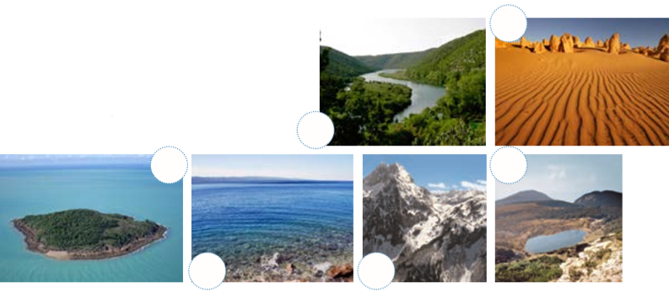
6
5
4
3
2
1

Lesson 2 A beautiful planet
1
1 islands 2 river 3 desert 4 sea 5 mountain 6 lakes
2
1 b) 2 a) 3 a) 4 b) 5 b)
3
1 Australia. 2 London. 3 English. 4 50. 5 Africa. 6 A monster.
7 Mount Everest. 8 Ten.
4 a)
1 popular 2 huge 3 clear 4 cold 5 tourists 6 covered
7 city 8 legend
4 b)
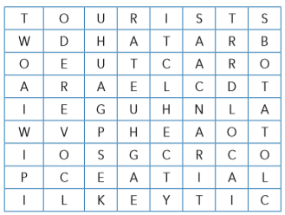

4 c)
What about Croatia?
What is Croatia like?
4 d)
Students’ own ideas.

Lesson 3 Around Croatia
1
long – short hard – easy fast – slow
big – small good – bad young – old
happy – sad hot – cold dry – wet
2
young | younger
long | longer
big | bigger
happy | happier
fast | faster
wet | wetter
dry | drier
hard | harder
easy | easier
slow | slower
hot | hotter
bad | worse
good | better
3 Suggested answers:
My sister is faster than my brother.
I am better at school than my best friend.
Maths is easier than Science.

Lesson 4 Exploring the world
1
Short adjectives | Long adjectives
brave, short, sporty, high, brave, lazy, tidy, funny, kind, calm | interesting, difficult, nervous, patient, dangerous, comfortable, interesting, hard- working, curious, boring
2
1 lazier 2 more patient 3 more curious 4 more dangerous
5 more comfortable 6 braver 7 more famous 8 calmer 9 sportier
10 more boring
3 a)
1 warmer 2 more popular 3 longer 4 more interesting
5 more famous 6 better 7 healthier 8 worse
3 b)
Students’ own answers.
4 Suggested answers:
1 better 2 easier 3 more interesting 4 more hard-working 5 longer
6 faster
5 Possible answers:
Flying in a plane is faster than driving in a car.
Dolphins are more friendly than the whales.
Science is more exciting than maths.

Lesson 5 Not so ordinary hobbies
1
1 today, every day 2 Every morning/ This morning 3 Every evening, now
4 at the moment, usually
2
1 delivers mail, he is washing his car
2 takes photos, she is singing in a choir
3 fixes people’s teeth, he is reading a book
4 helps patients, is helping her mum
3
1 watch 2 am reading 3 go 4 are visiting, am throwing 5 travel
6 is spending

Lesson 6 What’s the weather like?
1
January May September
February June October
March July November
April August December
2
1 winter 2 summer 3 spring 4 autumn
3 a)
Parts of the day | Days of the week | Months | Seasons
evening, morning, night, afternoon | Wednesday, Tuesday, Thursday, Saturday | July, August, June, December | winter, autumn, spring, summer
3 b)
1 morning, night
2 Saturdays and Sundays
3 Tuesday
4 winter, summer
5 July
6 December
4
It’s sunny. | It’s cold. | It’s cloudy. | It’s windy.
It’s hot. | It’s foggy. | It’s snowing. | It’s raining.
5 Project time
Students’ own projects.

Lesson 7 Tia’s year
1
1 a) 2 b) 3 a) 4 a) 5 a)
2
cold, cards, birthday, celebrate, outdoors, summer, seaside, farm, school, masks. holidays, shopping
Lesson 8 The Wind and the Sun
1
8_ Be in a place where nobody can see you.
5_ Unhappy because something is not as you would like it to be.
1 Not weak.
7_ You do that when it’s very hot.
2_ You do that when you are angry.
4__ Winds do that.
6__ Make bright light.
3__ You do that with a coat when it’s hot.
2 a)
4 his coat.
5 shine at the man.
1 the Sun.
6 off.
2 stronger.
7 the winner.
3 a man in a blue coat.
2 b) Students retell the story.

Self-check 6
VOCABULARY
1
1 March. 2 December. 3 May. 4 October. 5 January. 6 August.
2
1 lake 2 river 3 desert 4 country 5 mountain 6 islands
3
Its’ foggy. | It’s cloudy. | It’s windy.
GRAMMAR
1
1 older 2 easier 3 more popular 4 worse 5 more interesting
6 higher 7 better 8 more famous 9 bigger
2
1 I sometimes 2 Now 3 often
3
1 goes 2 is watching 3 stays 4 are playing 5 get
6 are sleeping

UNIT 7
Lesson 1 Animal world: high and low
1
domestic | wild
a dog, a pig, a cat, a sheep, a cow | a dolphin, a butterfly, a shark, a whale, a fox, a bear, a stork,
2
1 a stork, a butterfly
2 a whale, a shark
3 a dog, a cat, a fox
Students add more animal to the list.
3
1 a dog 2 a cat 3 a whale 4 a bear 5 a butterfly 6 a shark
Suggested descriptions:
It is red. It lives in a forest. It has got a bushy tail. It’s dangerous.
It has four legs. It gives milk. It lives on a farm.

Lesson 2 Animal world: Hot and cold
1
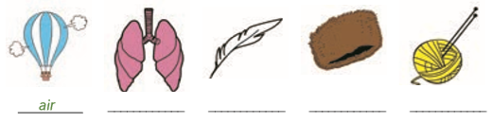
fur
a feather
wool
lungs
2 warm, together, next to, birds, see
summer, ears, camels, plants
3
Adjectives from the textbook | New adjectives
woolly, thick, white | long
strong, short, long | hairy
small | gigantic
big | red

Lesson 3 A class of their own
1 Possible answers:
1 (a classmate’s name) 2 (a classmate’s name) 3 maths 4 football 5 Mozart
2
A tallest B fastest C smallest D fastest E biggest F fastest
G slowest
3

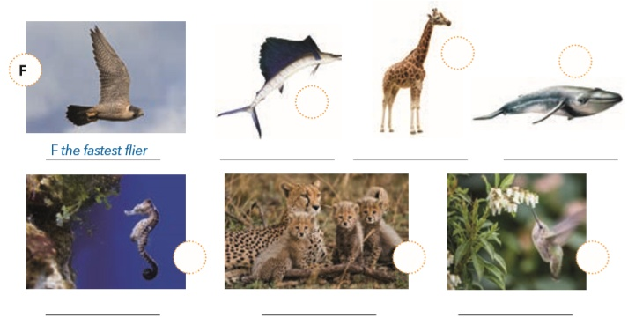
the world's biggest animal
the smallest bird
the fastest land animal
the slowest swimmer
the tallest animal
the fastest fish
C
D
G
E
A
B

Lesson 4 Be what you want to be
1 Students’ own ideas.
2
3__ not like anything else
4__ a car race
1 people wear it on their heads
5__ old-fashioned, usual
2__ people walking and celebrating something
6__ you can’t see it often
3
The strawberry cake is the small. The yellow T-shirt is expensive.
The lemon cake is smaller. The blue T-shirt is more expensive.
The chocolate cake is the smallest. The purple T-shirt is the most expensive.

Lesson 5 Simply the best 1
1
1 Xie Qiuping 2 Brett Williams 3 Kane Tanaka 4 Christian Coleman
5 Houdini
2
1 fur 2 tricks 3 Business 4 make 5 grapes
3
36.5 Franchesca’s fur is 36.5 cm long.
32 Smurf can do 32 tricks in one minute.
24 Ernestine is over 24 years old.
17 Ernestine was born on the 17th of July in 1991.
6 Smurf is 6-year-old.

Lesson 6 Simply the best 2
1 happy, the loudest, leaves, talking, snail, girlfriend, fastest
2
NAME | ANIMAL | COUNTRY | WHAT IS SPECIAL?
Smurf | a dog | UK | Smurf can do tricks.
Ernestine | a pig | CANADA | She is the oldest pig ever.
Franchesca | an Angora rabbit | USA | She’s the rabbit with the longest fur in the world.
Bertie | a tortoise | UK | Bertie is the world’s fastest tortoise.
Merlin | a cat | UK | She is the cat with the loudest purr ever.

Lesson 7 At the shop
1
1 vet 2 collar 3 leash 4 bowl 5 carrier 6 litter
2
2 It’s for a cat.
3 I’d like the smaller bag, please.
1 I need some food for my pet.
5 It’s £5.
4 Yes, it is.
3 Students’ own ideas.

Lesson 8 The great pet dilemma
1,2,3 and 4 Students’ own answers and presentations.

Self-check 7
VOCABULARY
1
1 breathe land 3 air 4 endangered 5 keeps 6 water
2
1 breed 2 long 3 the 4 takes 5 is 6 lay
3
2 it’s what keeps dogs and cats warm
3 the sand you put in your pet’s toilet
1 they keep birds warm
5 round metal money
4 dogs wear it around their neck
4
A: think, need B: agree, because
GRAMMAR
1
short | long
the highest, the fastest, the happiest, the coldest | the most original, the most famous, the most important, the most colourful
2
1 the coldest 2 the most famous 3 The most important 4 the highest
5 the fastest 6 the most original
3
1 the youngest 2 smaller 3 more popular 4 better 5 hotter
6 the most difficult
4
1 the oldest 2 the deepest 3 taller 4 more stubborn 5 the most unusual
UNIT 8
Lesson 1 Want to be fit?
1
1 sports, homework
2 time, money
3 healthy, fit
4 breakfast, classes
5 toothache, breakfast
6 teeth, hair
7 a hike, a ride
8 energy for the day, ill
2 fit, breakfast, energy for the day, teeth, toothache, time, sports, a hike
3 Students’ own answers.

Lesson 2 Water’s the best
1 a) apple pie, meat, bread, pancakes, milk, cheese, fruit, vegetables, eggs, bacon, butter, cereal, soup, potatoes
1 b)
breakfast | lunch | dessert
bread, milk, cheese, fruit, eggs, bacon, butter, cereal | meat, vegetables, soup, potatoes | apple pie, pancakes
2 Students’ own answers.

Lesson 3 Last weekend
1
1 were, was 2 was, were 3 was, was 4 was, were 5 were, were 6 was, was
2 was, was, were, was, was, were, was, was, were, was, were, was, were, was, were
3
1 No, it wasn’t. It was rainy.
2 No, they weren’t.
3 No, I wasn’t.
4 Yes, they were.
5 No, it wasn’t.
6 No, I wasn’t.

Lesson 4 Andy’s week
1
1 phoned 2 skipped 3 celebrated 4 finished 5 missed 6 quizzed
7 travelled
2 visited, stayed, walked, looked, tried, was, decided, was, enjoyed, listened, were
3 Possible answers:
Last week I played with my friends a lot. We decided to spend time outdoors. We enjoyed the nice weather. We walked to the woods and played there. It was great.

Lesson 5 A hearth of gold
1
1 medicine 2 pocket money 3 border 4 raise 5 donate 6 record
2
5 concerts
3 shocked
1 a TV programme
2 the Net
4 a CD
3 watched, was, surfed, recorded, organised, the Doctors Without Borders programme for the children in Africa

Lesson 6 What happened?
1
I don’t feel well.
Yes, it’s high. Very high.
All the time. I cough, too.
Yes. I need tissues all the time.
Aah!
What should I do?
Can I watch TV and play video games?
Thank you, doctor.
2
1 Jessica’s day was great.
2 Jesse’s day was awful.
3 Because he missed the bus.
4 She walked.
5 Because he was late for school again.
6 Because she answered all the questions right.
7 Because he was ashamed, and his parents were disappointed.
8 Jessica’s parents organised a party to celebrate their grandma’s 90th birthday.

Self check 8
VOCABULARY
1
1 Orange 2 Ice 3 chocolate 4 hot 5cheese 6 Apple
2
1 be, do, go 2 get 3 spend, play
3
1 donate 2 spend 3 brush 4 skip 5 surf 6 organise
GRAMMAR
1
1 was 2 was 3 were 4 was 5 were 6 Was
2
1 were, was, was, were, was 2 was, was, were
3
1 visited 2 watched 3 tidied 4 stayed 5 danced
4 Possible answers:
I celebrated my friend’s birthday. I studied for the test.

